**Template for Properly Formatted Images of Note Submissions**

*author #1*

*Affiliation #1, City, State or Country*

*author #2*

*Affiliation #1, City, State or Country*

(Manuscript received Day Month Year; review completed Day Month Year)

**1. Introduction**

Abstracts are not used for *Images of Note* submissions. This section should provide some context leading up to the imagery. Succinctly discuss the purpose of your note, as well as prior research relevant to your paper. Do not reference the figures in this section. Citations should be chronological and not alphabetical (i.e., Davies-Jones 1984, 1986; Bunkers et al. 2000); however, the reference list at the end of the paper should be alphabetical. Markowski’s (2002) review paper is rich with references, so you also can consult that for general guidance. Notice how commas and semicolons were used—and not used—in the above citations.

**2. Discussion**

This should be the focus of your paper. This is where the figures should be discussed. What phenomena are depicted in the images? Why are these phenomena important to operational meteorology? The text should describe and evaluate the atmospheric processes at work in the imagery. Relate your discussion of the imagery to the references included in the Introduction. Briefly describe the datasets used to create the imagery.

Use the same font style and sizes as shown in this template. Use 2.54-cm (1-in) margins and 0.635-cm (0.25-in) tabs for new paragraphs as set here. Adhere to SI units whenever possible with English units in parentheses (refer to the previous sentence). The JOM convention is to use “kt” for knots, “in” for inches, “n mi” for nautical miles, “lb” for pounds, and “ft” for feet (note the lack of periods for the English abbreviations). Define all non-standard acronyms when they first appear, and then stick with the acronym thereafter. Note that only the first word of the section titles is capitalized (e.g., see title for section 2). Commas are required after “i.e.” and “e.g.” as shown in the previous sentence. Note that “n” dashes are used for ranges of values and regular dashes are used for hyphenation, respectively (e.g., the 0−1-km shear was favorable tornadoes).

The total number of double-spaced pages cannot exceed four, including the title and body. Acknowledgments, references, figures, and tables (e.g., Table 1) are *excluded* from this four-page limit. If you exceed the four-page limit, your paper will be returned either for revision or consideration as a Short Contribution for the JOM. If accepted for publication, your paper will be in a single-spaced, double-column format, with the figures and tables embedded at appropriate places within the document.

Cite figures chronologically. Always abbreviate figures (e.g., Fig. 1) unless they begin a sentence. Figure 2 is an example of an appropriate figure. Moreover, figures should be placed at the end of the paper for the review process. If you include an animation as part of the figure, please include a link to that animation as shown in Fig. 2. State names are not abbreviated in the main body of the paper, but they are abbreviated in table and figure captions (e.g., Fig. 2).

The review process and technical editing can be slowed considerably if (1) figures, tables, and references are not cited properly throughout the manuscript or (2) the reference list contains multiple errors, is improperly formatted, or is incomplete. Depending upon the extent of improper citing and formatting, the manuscript may be returned to the author before entering review and/or technical editing.

**3. Summary**

As briefly as possible, summarize what was presented in the previous two sections. A bulleted list often works well here; please see Geerts (1999) for a discussion of this. Speculation should be kept at a minimum. Ensure the key point of your work is clear.

*Acknowledgments*. Remember to thank people who helped you.

References

Bunkers, M. J., B. A. Klimowski, J. W. Zeitler, R. L. Thompson, and M. L. Weisman, 2000: Predicting supercell motion using a new hodograph technique. *Wea. Forecasting*, **15**, 61–79, [CrossRef](http://dx.doi.org/10.1175/1520-0434(2000)015%3C0061:PSMUAN%3E2.0.CO;2).

Davies-Jones, R., 1984: Streamwise vorticity: The origin of updraft rotation in supercell storms. *J. Atmos. Sci.*, **41**, 2991–3006, [CrossRef](http://dx.doi.org/10.1175/1520-0469(1984)041%3C2991:SVTOOU%3E2.0.CO;2).

____, 1986: Tornado dynamics. *Thunderstorm Morphology and Dynamics*, E. Kessler, Ed., University of Oklahoma Press, 197–236.

Geerts, B., 1999: Trends in atmospheric science journals: A reader’s perspective. *Bull. Amer. Meteor. Soc.,* **80,** 639−651.

Markowski, P. M., 2002: Hook echoes and rear-flank downdrafts: A review. *Mon. Wea. Rev.*, **130**, 852–876, [CrossRef](http://dx.doi.org/10.1175/1520-0493(2002)130%3C0852:HEARFD%3E2.0.CO;2).

**TABLES AND FIGURES**

**Table 1.** Put the caption above the table. Use the following template for your tables. Ensure you have enough information in the caption to describe the table (e.g., dates, units, abbreviations).

|  |  |  |  |
| --- | --- | --- | --- |
|  | OUN, 5/30/2004 | BIS, 6/24/2002 | TFX, 8/6/2002 |
| Bulk0–8km | 30.8 m s-1 | 21.5 m s-1 | 43.1 m s-1 |
| SRW8km | 22.6 m s-1 | 6.7 m s-1 | 24.8 m s-1 |
| MLBRN | 40 | 18 | 7 |
| MLLCL | 1272 m | 1167 m | 1258 m |
| MLCAPE | 2214 J kg-1 | 2483 J kg-1 | 719 J kg-1 |
| MLCIN | 64 J kg-1 | 9 J kg-1 | 127 J kg-1 |
| SRH0–3km | 256 m2 s-2 | 341 m2 s-2 | 274 m2 s-2 |

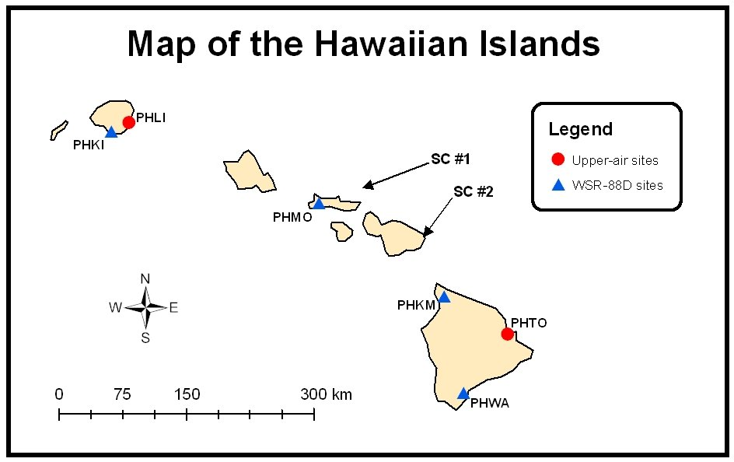

**Figure 1.** Put figure captions below each figure. Figure captions can be single-spaced. Figures should be clearly legible with the font sufficiently large so you can read it. Include distance scales and north arrows when needed, such as in this case. Keep figures on separate pages for ease of review. Similar figures can have the same number but different letters (e.g., Figs. 1a, 1b, and 1c). *Click image for an external version; this applies to all figures hereafter*.

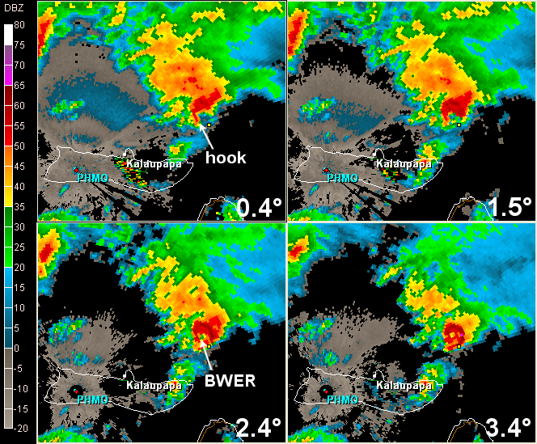

**Figure 2.** Radar reflectivity at 0012 UTC 30 October 2000 for the lowest four elevation angles (as annotated) from Molokai, HI (PHMO). The heights AGL of the storm centroid at each progressive angle are 687, 1751, 2738, and 3662 m (2254, 5744, 8982, and 12011 ft, respectively). A small yellow fiducial mark is indicated on each frame to illustrate midlevel overhang. The distance across an individual frame is 102 km (55 n mi). *Click image for animation*.