Template for Properly Formatted Short Contribution Submissions

author #1
Affiliation #1, City, State or Country

author #2
Affiliation #1, City, State or Country

(Manuscript received Day Month Year; review completed Day Month Year)

ABSTRACT
Keep this short and to the point. Do not use references in the abstract. Strive for only one or two paragraphs; the abstract should never be more than one page or 250 words. It will be single spaced when published, and that is also permissible for the review. The following section titles are only suggestions, but you should follow common practice.

1. Introduction

Discuss prior research relevant to your paper, state the problem or problems that still exist, and discuss how you plan to solve the supposed problem(s). Schultz (2009, 2010) has valuable guidance for various aspects of writing—including case studies. Citations should be chronological and not alphabetical (i.e., Davies-Jones 1984, 1986; Bunkers et al. 2000); however, the reference list at the end of the paper should be alphabetical. Markowski’s (2002) review paper is rich with references, so you can consult that for general guidance. Notice how commas and semicolons were used—and not used—in the above citations.
Use the same font style and sizes as shown in this template. Use 2.54-cm (1-in) margins and 0.635-cm (0.25-in) tabs for new paragraphs as set here. Adhere to SI units whenever possible with English units in parentheses (refer to the previous sentence). The JOM convention is to use “kt” for knots, “in” for inches, “n mi” for nautical miles, “lb” for pounds, and “ft” for feet (note the lack of periods for the English abbreviations). Define all non-standard acronyms when they first appear, and then stick with the acronym thereafter. Note that only the first word of the section titles is capitalized (e.g., see title for section 2). Commas are required after “i.e.” and “e.g.” as shown in the previous sentence.
The total number of double-spaced pages cannot exceed 10, including the title, abstract, and body. Acknowledgments, references, figures, and tables are excluded from this 10-page limit. If you exceed the 10-page limit, your paper will be returned either for revision or consideration as a full Article for the JOM. If accepted for publication, your paper will be in a single-spaced, double-column format, with the figures and tables embedded at appropriate places within the document.

2. Data and methods

A section on data and methods is customary. Two sections may be appropriate if the data and methods are important enough to stand on their own. Describe your data sources, collection, and quality control. Ensure your methods are described sufficiently such that your study is reproducible. If you have ancillary data, equations, or methods, that would be appropriate for an appendix; refer to Appendix A for formatting and placement of appendices and equations.

3. Analysis

This is the bulk of your paper. Cite figures chronologically. Always abbreviate figures (e.g., Fig. 1) unless they begin a sentence. Figure 2 is an example of an appropriate figure. Moreover, figures should be placed at the end of the paper for the review process. If you include an animation as part of the figure, please include a link to that animation as shown in Fig. 2. Never abbreviate when citing tables, but do include them at the end of the paper in chronological order, separate from and before the figures (Table 1). State names are not abbreviated in the main body of the paper, but they are abbreviated in table and figure captions (e.g., Fig. 2).
The review process and technical editing can be slowed considerably if (1) figures, tables, and references are not cited properly throughout the manuscript or (2) the reference list contains multiple errors, is improperly formatted, or is incomplete. Depending upon the extent of improper citing and formatting, the manuscript may be returned to the author before entering review and/or technical editing.

a. Evidence of supercells on Mars

Subsections should be italicized and lettered as shown here. Note the section letter still begins at the standard left margin. Note that “n” dashes are used for ranges of values and regular dashes are used for hyphenation, respectively (e.g., the 0−1-km shear was favorable tornadoes).

1) The 1800 UTC 29 September 1969 event

You even can have sub-subsections. The numbered headings are in small caps, and indented 0.635 cm (0.25 in). Dates throughout the paper should follow the format in this heading (i.e., hour UTC day month year).

4. Discussion

A discussion section is customary, or alternatively you could have an “Analysis and discussion” section. There is no hard and fast rule on this, but you should refer to Schultz (2009) if you have any questions. You should elaborate on your findings and place them in the context of previously published work; simply restating the facts without interpretation is not sufficient. Note that the word “data” is plural.

5. Conclusions

This part of the paper can be either a general conclusion or a list of conclusions and/or a summary (Schultz 2009). A bulleted list often works well here; please see Geerts (1999) for a discussion of this. Speculation should be kept at a minimum. Ensure the key points of your work are clear.

Acknowledgments. Remember to thank people who helped you.

APPENDIX A

The VCE Method

The vertical change with elevation (VCE), sometimes called the lapse rate, plays a major role in how a datum affects a grid point. Consider station A with a specific temperature value TA at elevation EA, and another station B a short distance away with a temperature value TB at elevation EB. To apply a correction based on station A to a grid point near station B, one needs to consider that the correction should be based on the VCE, defined as:

$VCE= \frac{(TB-TA)}{(EB-EA)}$. (1)

The VCE is computed for each station for each analysis. The specific value for a station is based on several stations (B_{i}) that are close in horizontal distance and far apart in vertical distance, with the more stations the better. Thus,

$VCE\left(A\right)= {\sum{{(TB}_{i}-TA)}}/{\sum{{(EB}_{i}-EA)}}$ (2)

is the VCE summed over all designated close stations, B_{i}. This process is quite robust, computing only one statistic from several pieces of data. It is important to find a list of stations that are close in horizontal distance but far apart in vertical distance. A preprocessor finds such lists of stations by making several passes over the vertical and horizontal station locations, searching for the desired combinations.
In the analysis, the modifications to grid points from the stations within the radii of influence use not only the observation, but also the individual VCEs.

References
Bunkers, M. J., B. A. Klimowski, J. W. Zeitler, R. L. Thompson, and M. L. Weisman, 2000: Predicting supercell motion using a new hodograph technique. Wea. Forecasting, 15, 61–79, CrossRef.
Davies-Jones, R., 1984: Streamwise vorticity: The origin of updraft rotation in supercell storms. J. Atmos. Sci., 41, 2991–3006, CrossRef.
____, 1986: Tornado dynamics. Thunderstorm Morphology and Dynamics, E. Kessler, Ed., University of Oklahoma Press, 197–236.
Geerts, B., 1999: Trends in atmospheric science journals: A reader’s perspective. Bull. Amer. Meteor. Soc., 80, 639−651.
Markowski, P. M., 2002: Hook echoes and rear-flank downdrafts: A review. Mon. Wea. Rev., 130, 852–876, CrossRef.
Schultz, D. M., 2009: Eloquent Science: A Practical Guide to Becoming a Better Writer, Speaker, and Atmospheric Scientist. Amer. Meteor. Soc., 412 pp, CrossRef.
____, 2010: How to research and write effective case studies in meteorology. Electronic J. Severe Storms Meteor., 5 (2), 1–18. [Available online at www.ejssm.org/ojs/index.php/ejssm/issue/view/20.]

TABLES AND FIGURES

Table 1. Put the caption above the table. Use the following template for your tables. Ensure you have enough information in the caption to describe the table (e.g., dates, units, abbreviations).

 | OUN, 5/30/2004 | BIS, 6/24/2002 | TFX, 8/6/2002
Bulk_{0–8km} | 30.8 m s⁻¹ | 21.5 m s⁻¹ | 43.1 m s⁻¹
SRW_{8km} | 22.6 m s⁻¹ | 6.7 m s⁻¹ | 24.8 m s⁻¹
MLBRN | 40 | 18 | 7
MLLCL | 1272 m | 1167 m | 1258 m
MLCAPE | 2214 J kg⁻¹ | 2483 J kg⁻¹ | 719 J kg⁻¹
MLCIN | 64 J kg⁻¹ | 9 J kg⁻¹ | 127 J kg⁻¹
SRH_{0–3km} | 256 m² s⁻² | 341 m² s⁻² | 274 m² s⁻²

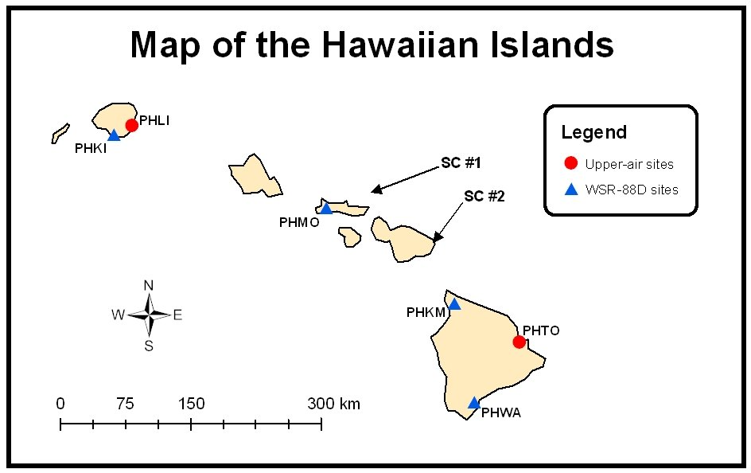

Figure 1. Put figure captions below each figure. Figure captions can be single spaced. Figures should be clearly legible with the font sufficiently large so you can read it. Include distance scales and north arrows when needed, such as in this case. Keep figures on separate pages for ease of review. Similar figures can have the same number but different letters (e.g., Figs. 1a, 1b, and 1c). Ensure you have enough information in the caption to describe the figure (e.g., dates, units, abbreviations). Click image for an external version; this applies to all figures hereafter.
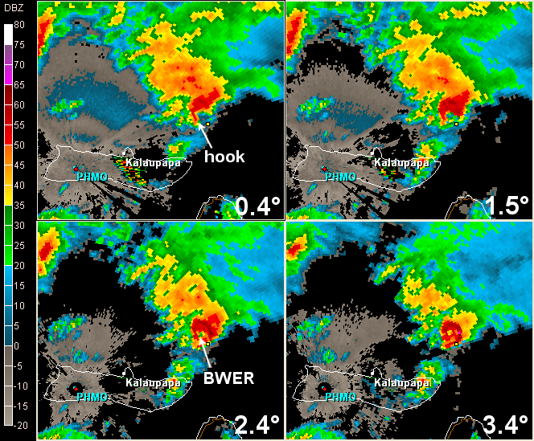

Figure 2. Radar reflectivity at 0012 UTC 30 October 2000 for the lowest four elevation angles (as annotated) from Molokai, HI (PHMO). The heights AGL of the storm centroid at each progressive angle are 687, 1751, 2738, and 3662 m (2254, 5744, 8982, and 12011 ft, respectively). A small yellow fiducial mark is indicated on each frame to illustrate midlevel overhang. The distance across an individual frame is 102 km (55 n mi). Click image for animation.

